MOD N-counter code:
library IEEE;
use IEEE.STD_LOGIC_1164.ALL;
use IEEE.NUMERIC_STD.ALL;
entity N_bit_counter is
generic (
N : integer := 4
);
Port (
clk : in STD_LOGIC;
reset : in STD_LOGIC;
count : out STD_LOGIC_VECTOR(N-1 downto 0)
);
end N_bit_counter;
architecture Behavioral of N_bit_counter is
signal counter : unsigned(N-1 downto 0) := (others => '0');
-- Clock divider counter
signal clk_div : unsigned(26 downto 0) := (others => '0');
-- Divided 1 Hz clock
signal clk_1Hz : STD_LOGIC := '0';
begin
-- Process 1: Divide 100 MHz clock to 1 Hz
process(clk, reset)
begin
if reset = '1' then
clk_div <= (others => '0');
clk_1Hz <= '0';
elsif rising_edge(clk) then
if clk_div = 49_999_999 then
clk_div <= (others => '0');
clk_1Hz <= not clk_1Hz;
else
clk_div <= clk_div + 1;
end if;
end if;
end process;
-- Process 2: Your original counter
process(clk_1Hz, reset)
begin
if reset = '1' then
counter <= (others => '0');
elsif rising_edge(clk_1Hz) then
if counter = 9 then
counter <= (others => '0');
else
counter <= counter + 1;
end if;
end if;
end process
count <= std_logic_vector(counter);
end Behavioral;

Test Bench code:-
library IEEE;
use IEEE.STD_LOGIC_1164.ALL;
entity N_bit_counter_tb is
end N_bit_counter_tb;
architecture Behavioral of N_bit_counter_tb is
-- Component Declaration
component N_bit_counter
generic (
N : integer := 4
);
Port (
clk : in STD_LOGIC;
reset : in STD_LOGIC;
count : out STD_LOGIC_VECTOR(N-1 downto 0)
);
end component;
-- Testbench signals
signal clk : STD_LOGIC := '0';
signal reset : STD_LOGIC := '0';
signal count : STD_LOGIC_VECTOR(3 downto 0);
begin
-- Instantiate DUT
uut: N_bit_counter
generic map (
N => 4
)
port map (
clk => clk,
reset => reset,
count => count
);
-- 100 MHz Clock
-- Period = 10 ns
clk_process : process
begin
while true loop
clk <= '0';
wait for 5 ns;
clk <= '1';
wait for 5 ns;
end loop;
end process;
-- Reset and simulation
stimulus_process : process
begin
-- Apply reset
reset <= '1';
wait for 100 ns;
-- Release reset
reset <= '0';
-- Wait for counter operation
wait for 2 sec;
-- Apply reset again
reset <= '1';
wait for 100 ns;
reset <= '0';
wait for 2 sec;

-- End simulation
wait;
end process;
end Behavioral;

Simulation Waveform:
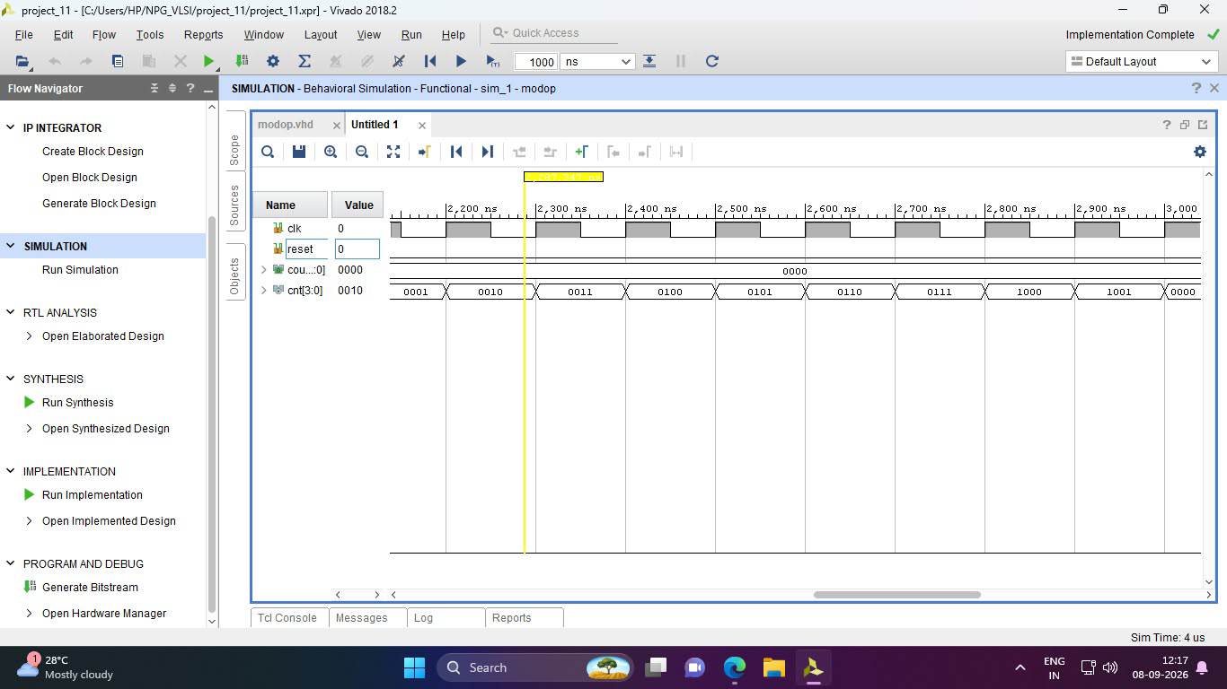

UCF code:-
set_property PACKAGE_PIN L1 [get_ports {count[3]}]
set_property PACKAGE_PIN P1 [get_ports {count[2]}]
set_property PACKAGE_PIN N3 [get_ports {count[1]}]
set_property PACKAGE_PIN P3 [get_ports {count[0]}]
set_property PACKAGE_PIN W5 [get_ports clk]
set_property PACKAGE_PIN R2 [get_ports reset]
set_property IOSTANDARD LVCMOS33 [get_ports {count[3]}]
set_property IOSTANDARD LVCMOS33 [get_ports {count[2]}]
set_property IOSTANDARD LVCMOS33 [get_ports {count[1]}]
set_property IOSTANDARD LVCMOS33 [get_ports {count[0]}]
set_property IOSTANDARD LVCMOS33 [get_ports clk]
set_property IOSTANDARD LVCMOS33 [get_ports reset]

